UNITED STATES

SECURITIES AND EXCHANGE COMMISSION
WASHINGTON, D.C. 20549

FORM 8-K

CURRENT REPORT

Pursuant to Section 13 or 15(d)
of the Securities Exchange Act of 1934

Date of Report (Date of earliest event reported): March 3, 2025

Rapport Therapeutics, Inc.

(Exact name of Registrant as Specified in Its Charter)

Delaware | 001-42121 | 88-0724208
(State or Other Jurisdiction | (Commission | (IRS Employer
of Incorporation) | File Number) | Identification No.)

1325 Boylston Street
Suite 401
Boston, Massachusetts | 02215
(Address of Principal Executive Offices) | (Zip Code)

Registrant’s Telephone Number, Including Area Code: 857 321-8020

Not Applicable

(Former Name or Former Address, if Changed Since Last Report)

Check the appropriate box below if the Form 8-K filing is intended to simultaneously satisfy the filing obligation of the registrant under any of the following provisions:

- Written communications pursuant to Rule 425 under the Securities Act (17 CFR 230.425)

- Soliciting material pursuant to Rule 14a-12 under the Exchange Act (17 CFR 240.14a-12)

- Pre-commencement communications pursuant to Rule 14d-2(b) under the Exchange Act (17 CFR 240.14d-2(b))

- Pre-commencement communications pursuant to Rule 13e-4(c) under the Exchange Act (17 CFR 240.13e-4(c))

Securities registered pursuant to Section 12(b) of the Act:

Title of each class |  | Trading |  | Name of each exchange
 |  | Symbol(s) |  | on which registered
Common Stock, $0.001 par value per share |  | RAPP |  | The Nasdaq Global Market

Indicate by check mark whether the registrant is an emerging growth company as defined in Rule 405 of the Securities Act of 1933 (§ 230.405 of this chapter) or Rule 12b-2 of the Securities Exchange Act of 1934 (§ 240.12b-2 of this chapter).

Emerging growth company ☒

If an emerging growth company, indicate by check mark if the registrant has elected not to use the extended transition period for complying with any new or revised financial accounting standards provided pursuant to Section 13(a) of the Exchange Act. ☐

Item 7.01 Regulation FD Disclosure.

On March 3, 2025, Rapport Therapeutics, Inc. (the “Company”) furnished its corporate presentation, attached as Exhibit 99.1 to this Current Report on Form 8-K in connection with the TD Cowen 45th Annual Health Care Conference today, March 3, 2025. The corporate presentation will also be available in the investor relations section of the Company’s website at www.rapportrx.com.

On March 3, 2025, the Company issued a press release announcing the appointment of Jeffrey Sevigny as Chief Medical Officer of the Company. A copy of this press release is furnished as Exhibit 99.2 to this Current Report on Form 8-K.

The information included under Item 7.01 of this Current Report on Form 8-K, including Exhibits 99.1 and 99.2, is being furnished and shall not be deemed “filed” for purposes of Section 18 of the Securities Exchange Act of 1934, as amended (the “Exchange Act”), or otherwise subject to the liabilities of that section, and shall not be incorporated by reference in any filing under the Securities Act of 1933, as amended, or the Exchange Act, except as expressly set forth by specific reference in such filing.

Item 8.01 Other Events.

On March 3, 2025, the Company announced, in its corporate presentation, timeline updates with regards to its Phase 2a trials of RAP-219 in refractory focal epilepsy and bipolar mania. The Company is currently conducting a Phase 2a proof-of-concept trial in adult patients with refractory focal epilepsy, for which it expects to report topline results in the third quarter of 2025. The Company also intends to initiate an additional Phase 2a trial of RAP-219 in bipolar mania in the third quarter of 2025 with topline data expected in the first half of 2027.

Forward-Looking Statements

The information under this Item 8.01 contains “forward-looking statements” of the Company within the meaning of the Private Securities Litigation Reform Act of 1995, as amended, including without limitation, express or implied statements regarding: the clinical development of RAP-219 for the treatment of refractory focal epilepsy and bipolar mania and the expected timing of the results from ongoing clinical trials.

Forward looking statements in this Item 8.01 are based on management’s current expectations and are subject to risks and uncertainties that could negatively affect the Company’s business, operating results, financial condition, and stock value. Factors that could cause actual results to differ materially from those currently anticipated include: risks relating to the Company’s research and development activities, including that interim, topline and preliminary data from our clinical trials that we announce or publish from time to time are subject to audit and verification procedures that could result in material changes in the final data; the Company’s ability to execute on its strategy including obtaining the requisite regulatory approvals on the expected timeline, if at all; uncertainties relating to preclinical and clinical development activities; the Company’s dependence on third parties to conduct clinical trials, manufacture its product candidates and develop and commercialize its product candidates, if approved; the Company’s ability to attract, integrate and retain key personnel; risks related to the company’s financial condition and need for substantial additional funds in order to complete development activities and commercialize a product candidate, if approved; risks related to regulatory developments and approval processes of the U.S. Food and Drug Administration and comparable foreign regulatory authorities; risks related to establishing and maintaining the Company’s intellectual property protections; and risks related to the competitive landscape for the Company’s product candidates; as well as other risks described in “Risk Factors,” in the Company’s Registration Statement on Form S-1, and most recent Quarterly Report on Form 10-Q, as well as discussions of potential risks, uncertainties, and other important factors in the Company’s subsequent filings with the Securities and Exchange Commission. The Company expressly disclaims any obligation or undertaking to release publicly any updates or revisions to any forward-looking statements contained herein to reflect any change in its expectations or any changes in events, conditions or circumstances on which any such statement is based, except as required by law, and claims the protection of the safe harbor for forward-looking statements contained in the Private Securities Litigation Reform Act of 1995.

Item 9.01 Financial Statements and Exhibits.

(d) Exhibits

99.1 Rapport Therapeutics, Inc. Corporate Presentation, March 2025, furnished hereto

99.2 Press Release dated March 3, 2025, furnished hereto

104 Cover Page Interactive Data File (embedded within the Inline XBRL document).

SIGNATURE

Pursuant to the requirements of the Securities Exchange Act of 1934, the registrant has duly caused this report to be signed on its behalf by the undersigned hereunto duly authorized.

Rapport Therapeutics, Inc.

Date: March 3, 2025 By: /s/ Troy Ignelzi

Troy Ignelzi

Chief Financial Officer



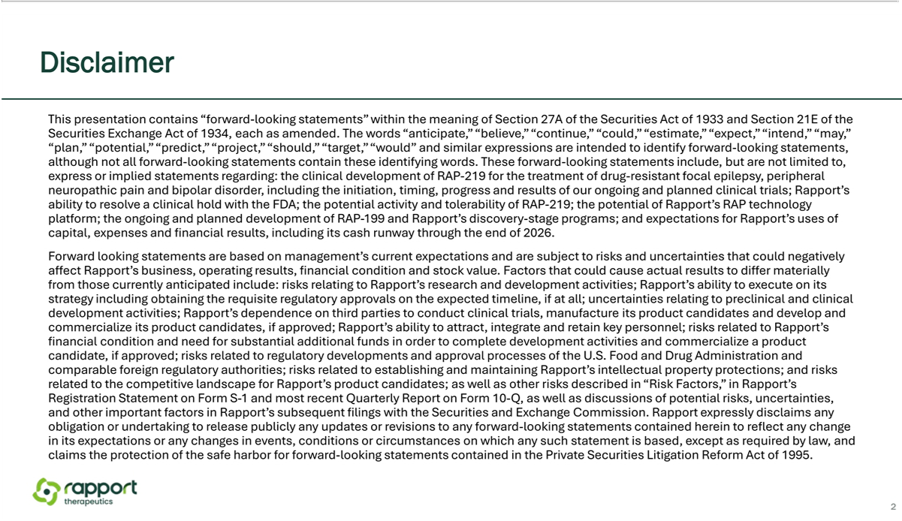

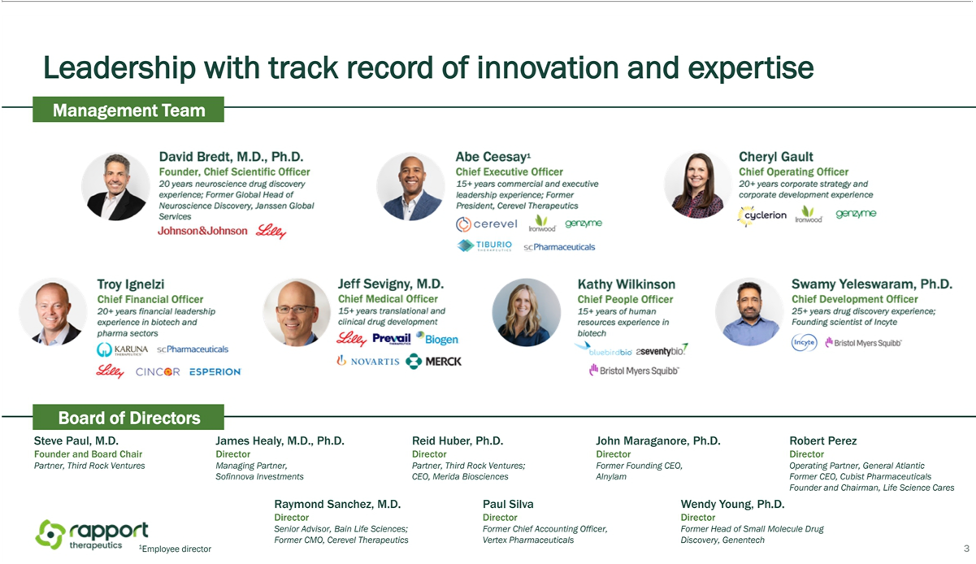

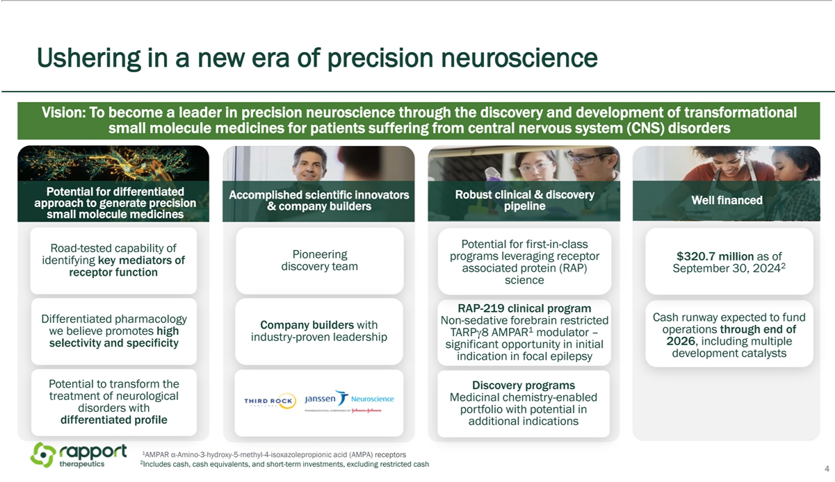

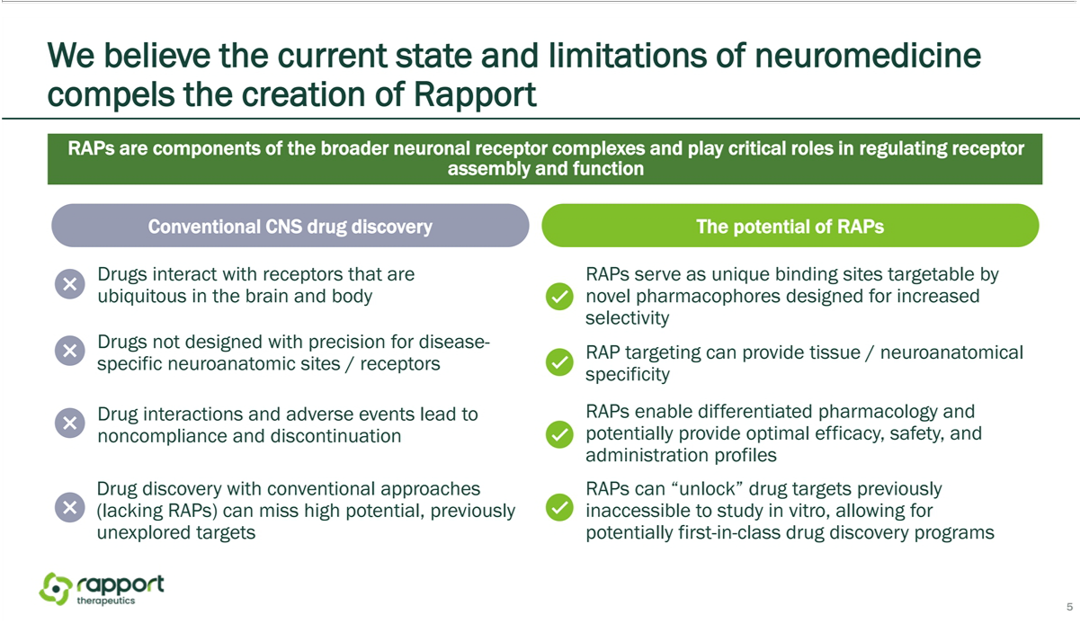

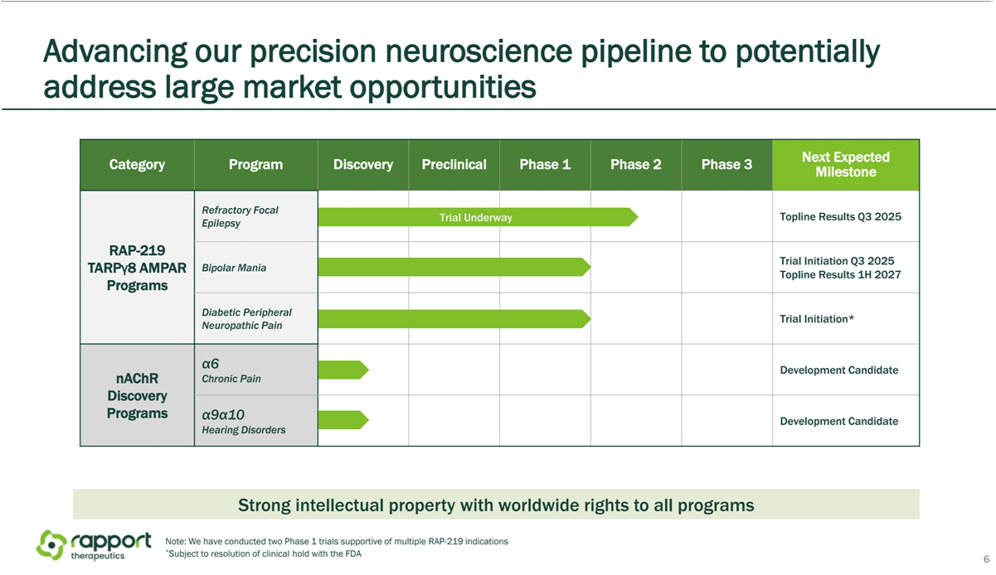

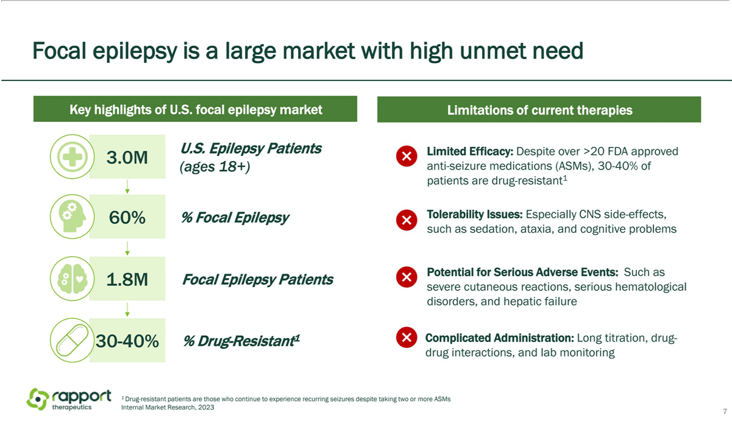

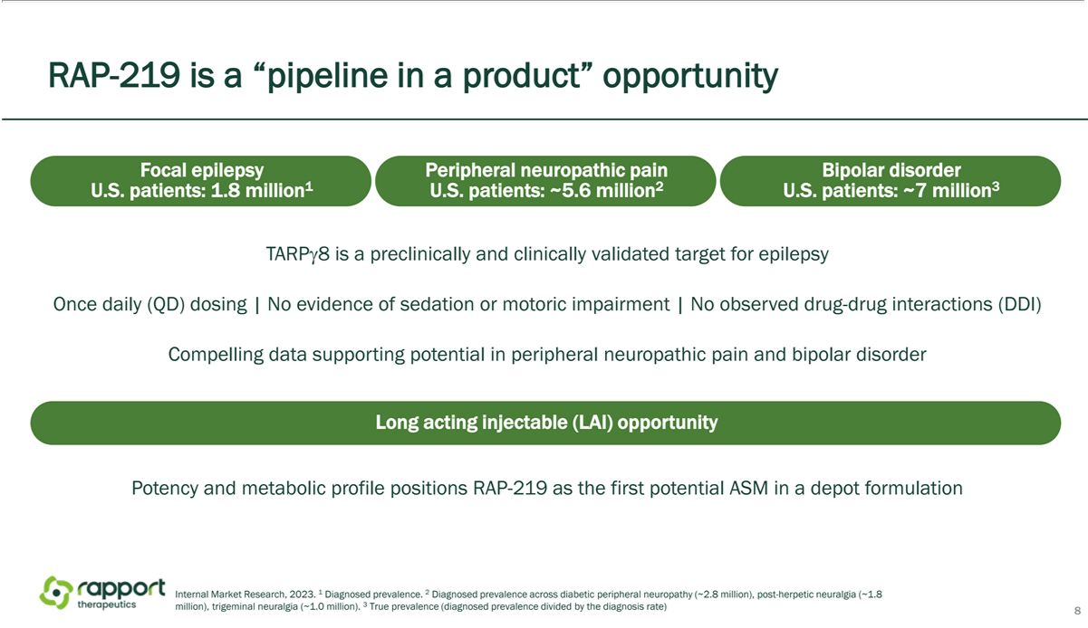

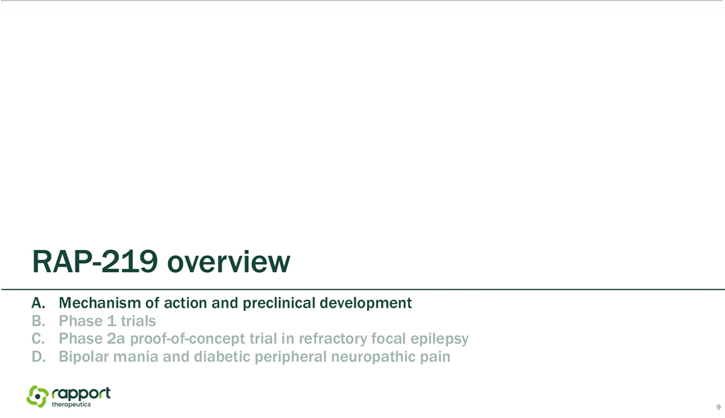

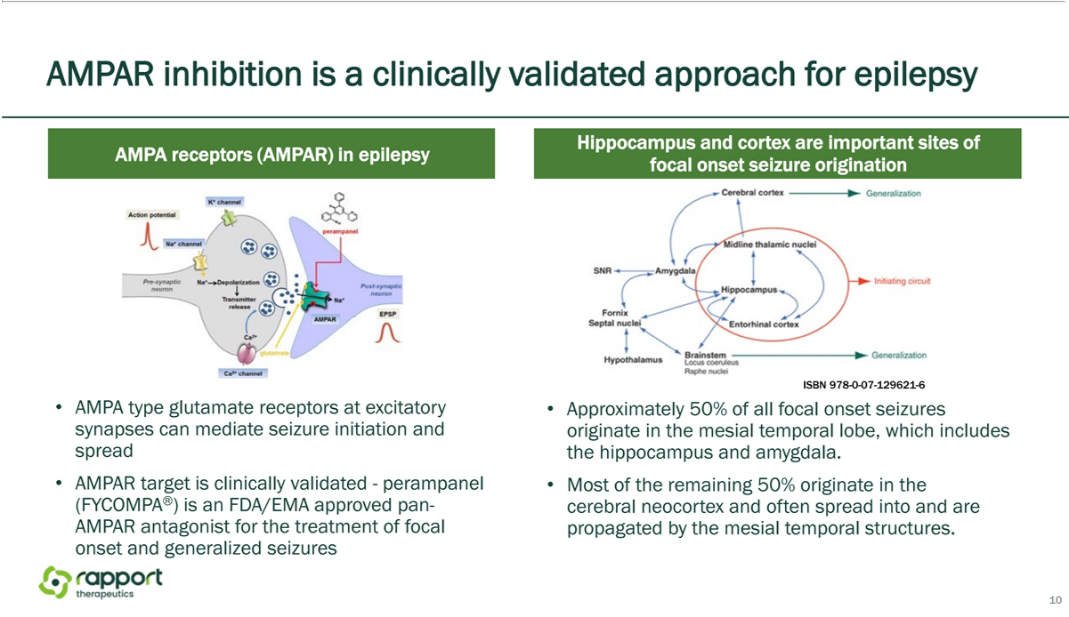

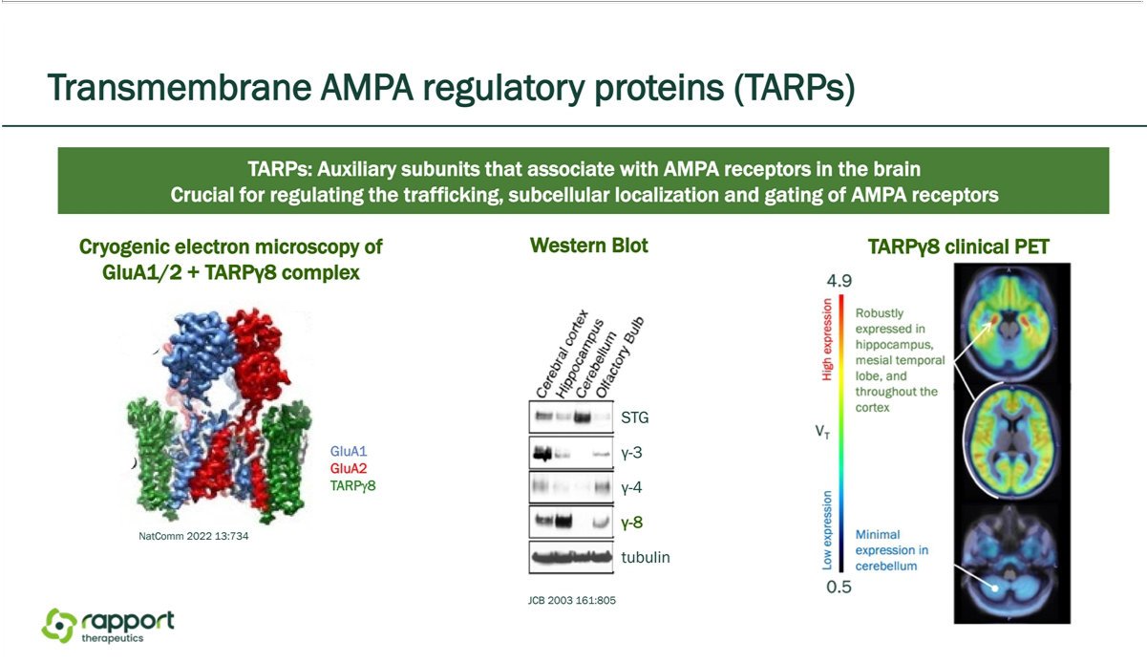

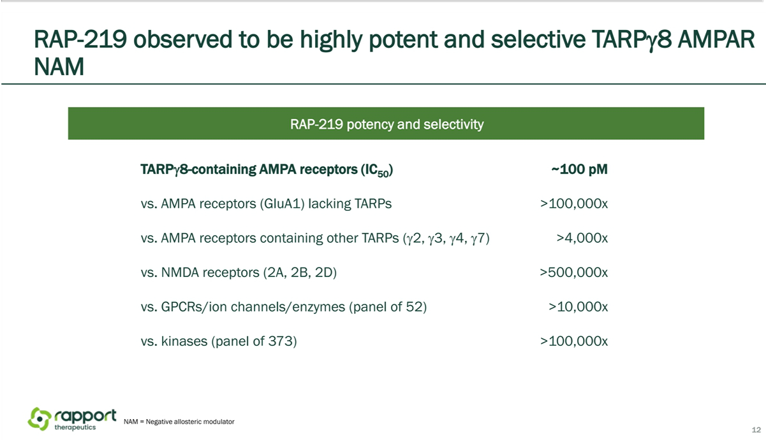

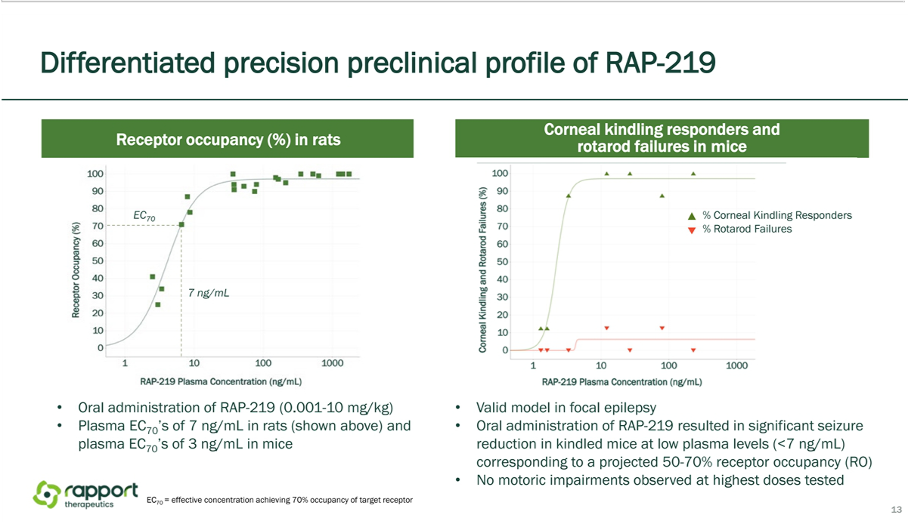

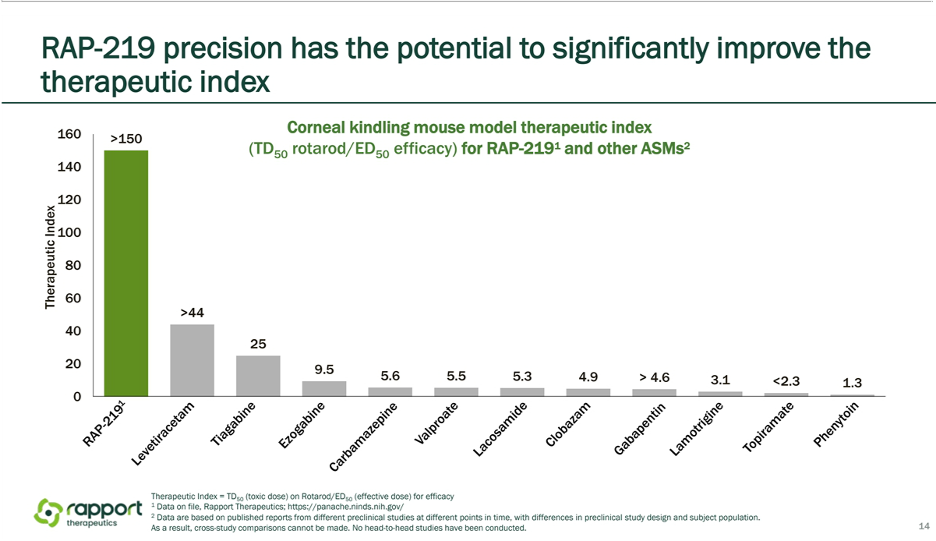

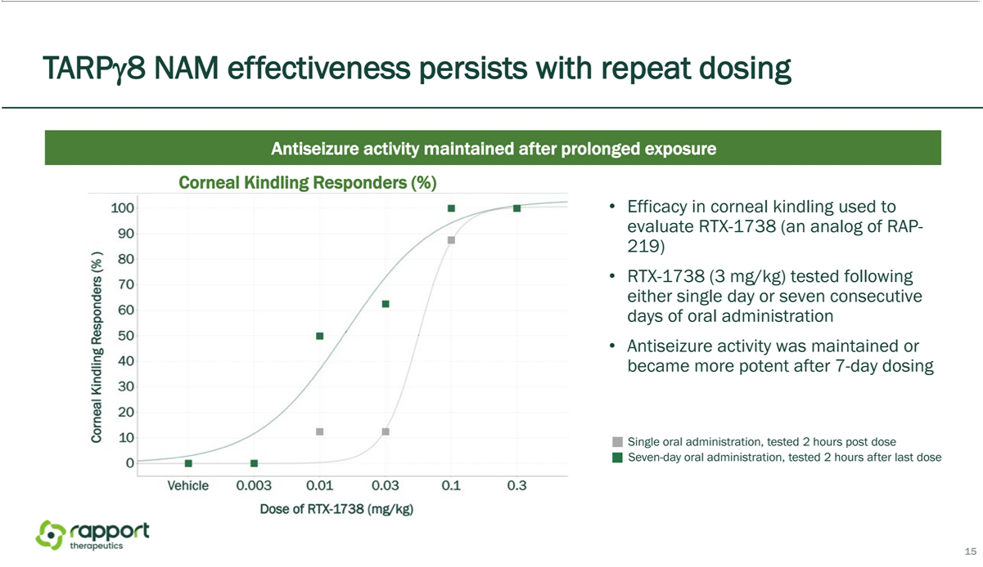

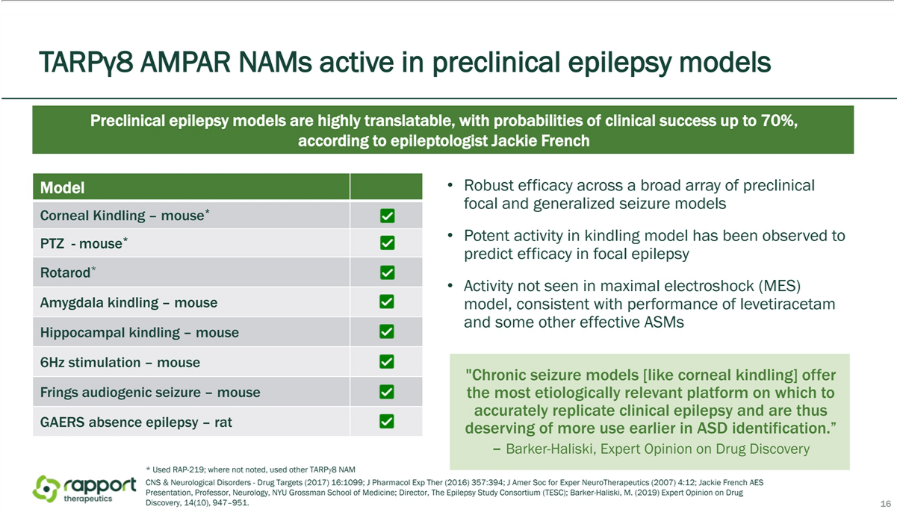

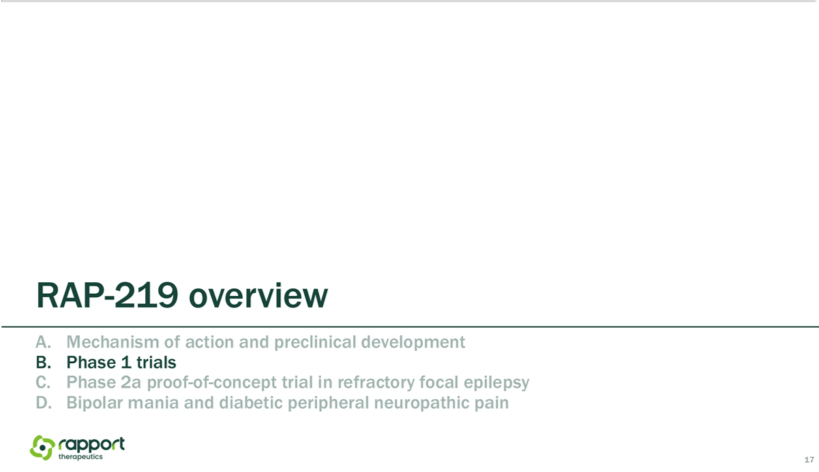

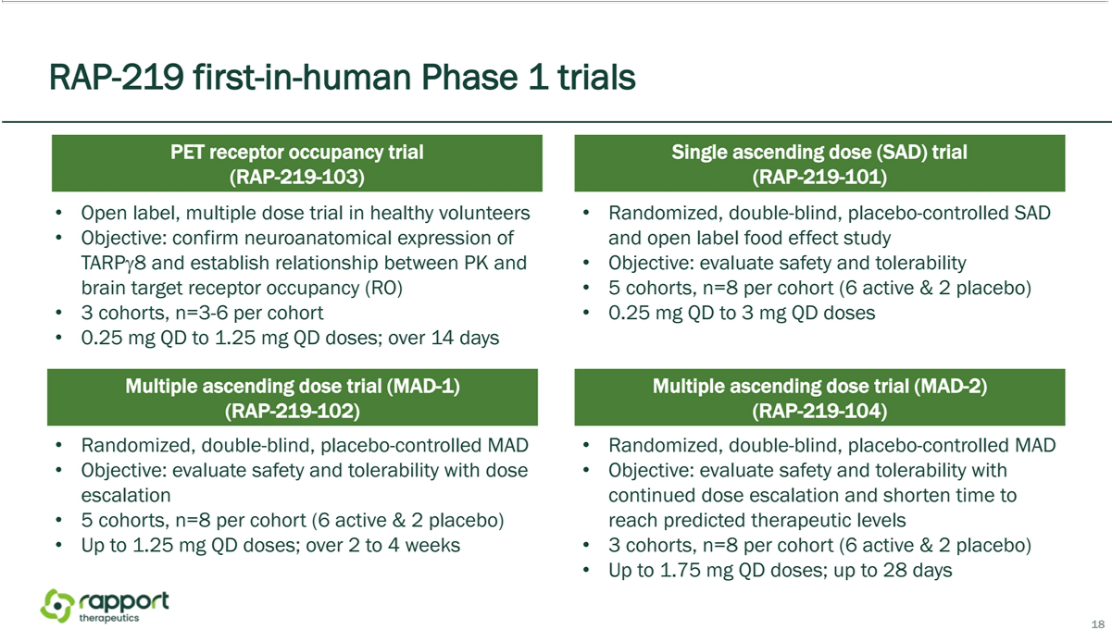

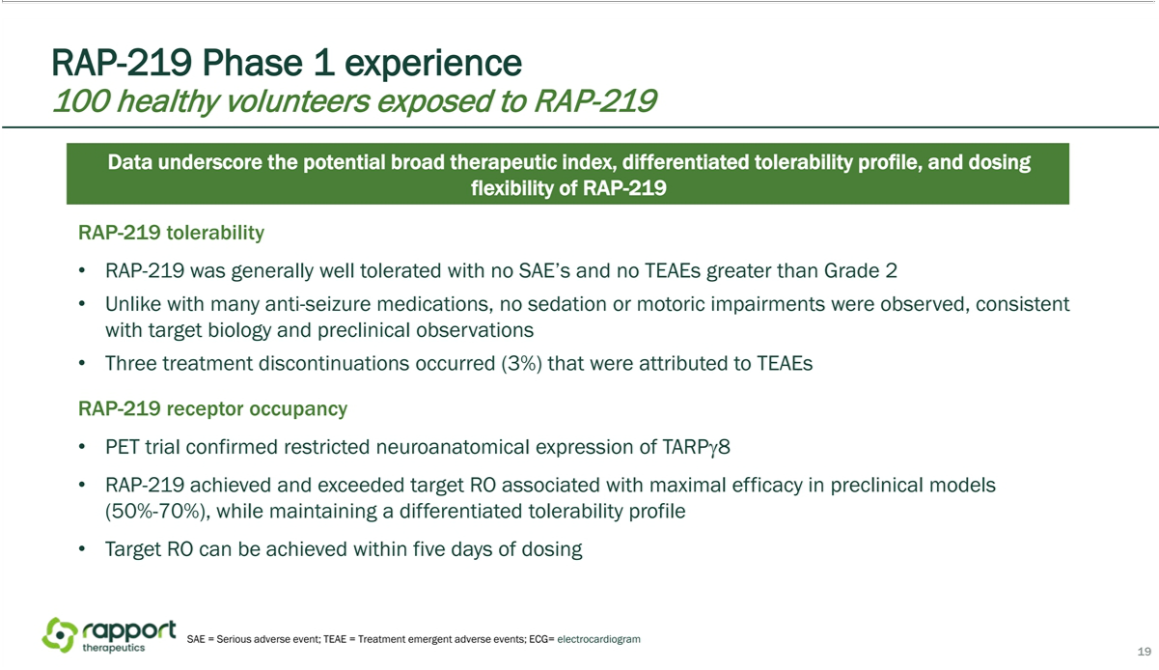

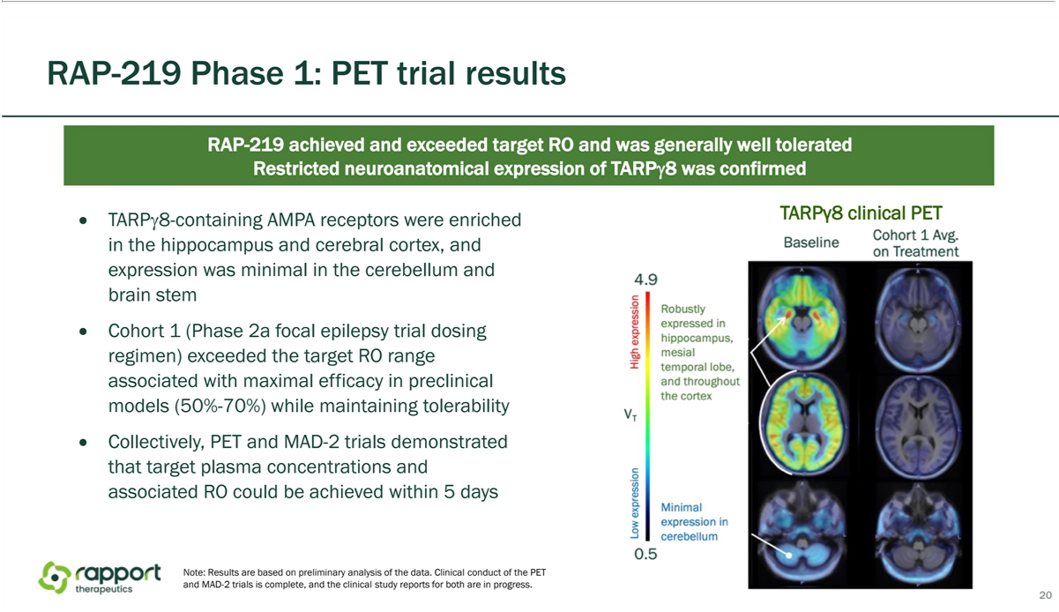

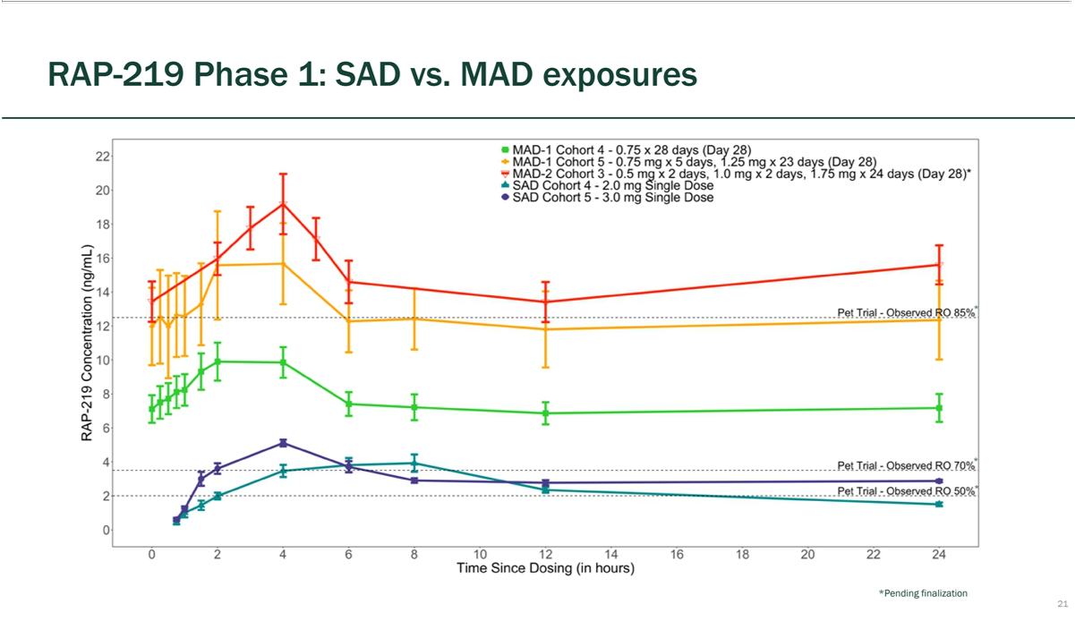

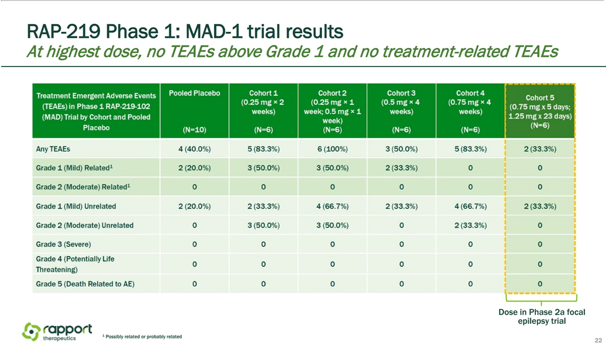

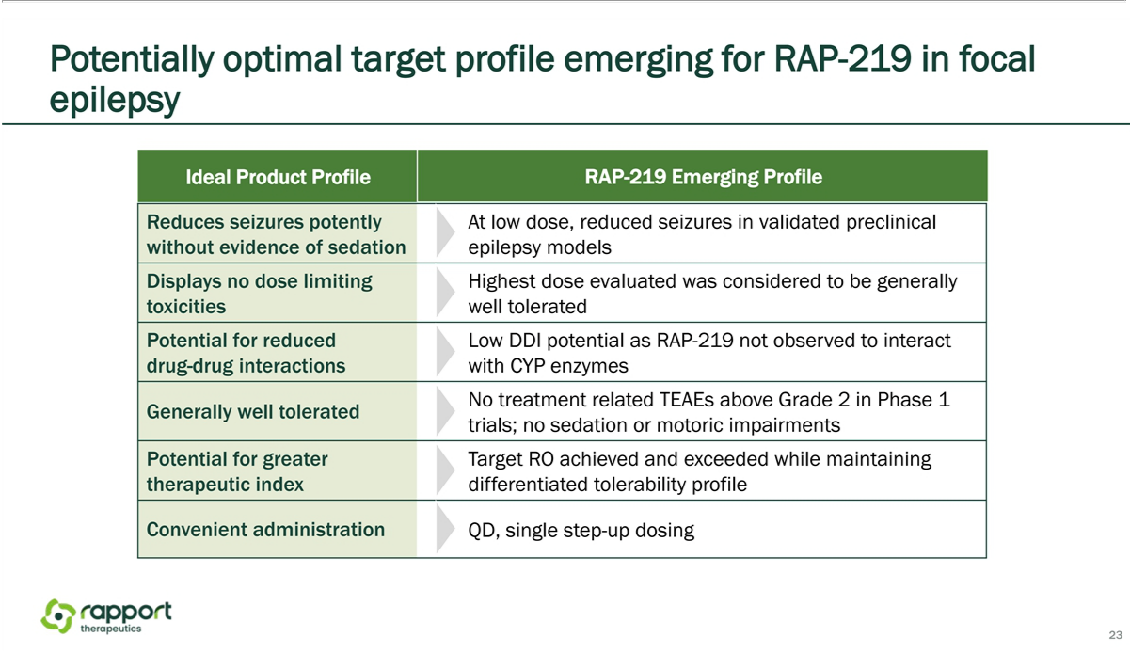

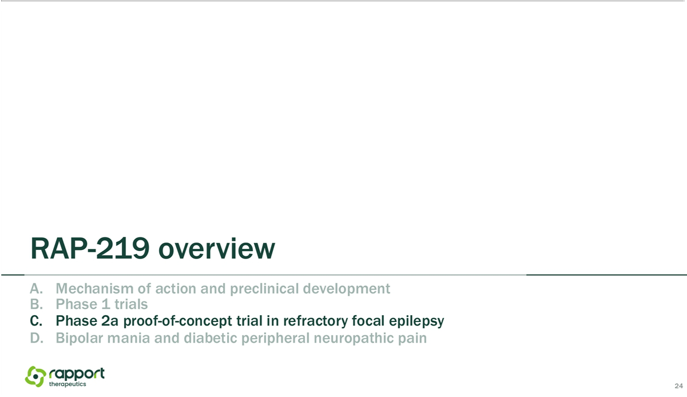

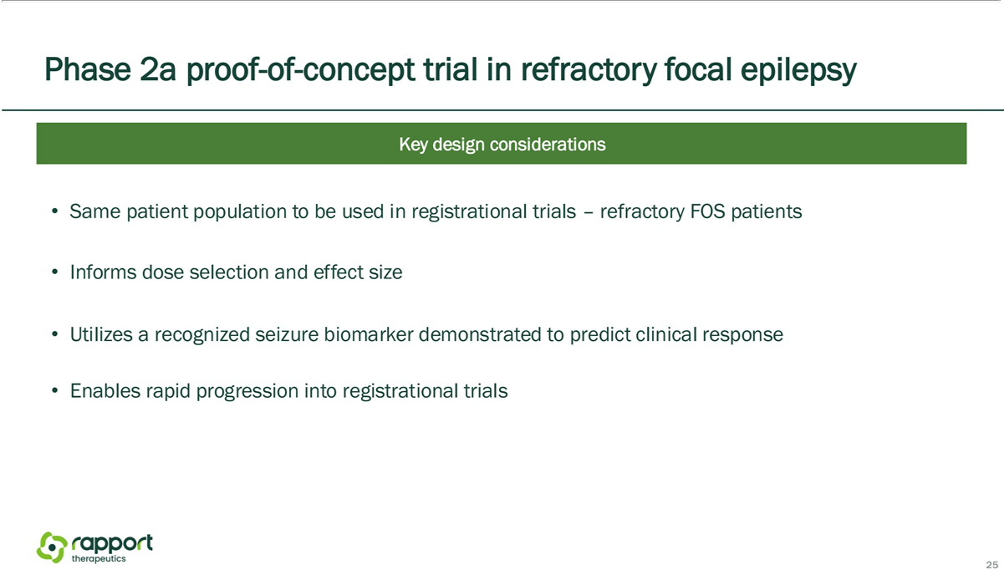

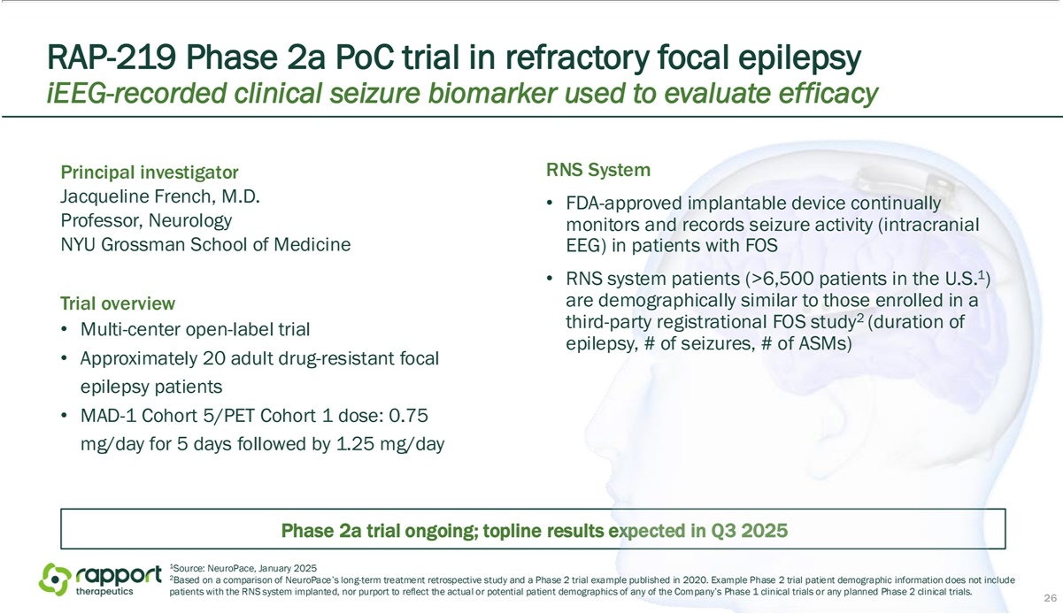

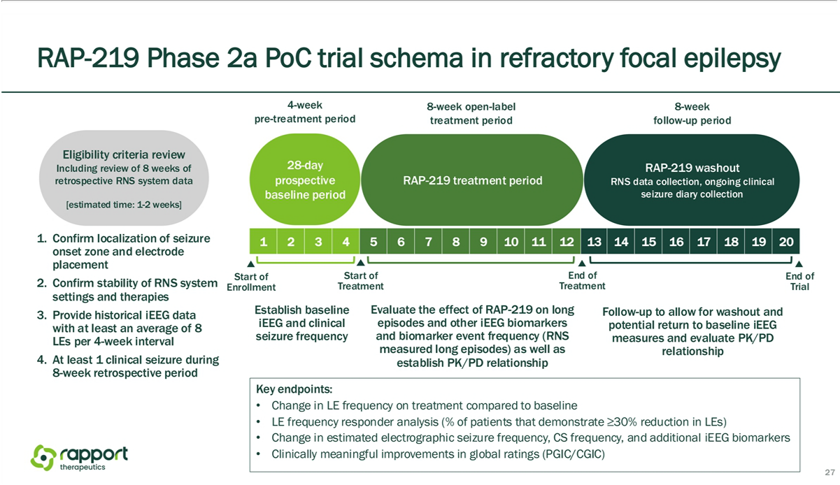

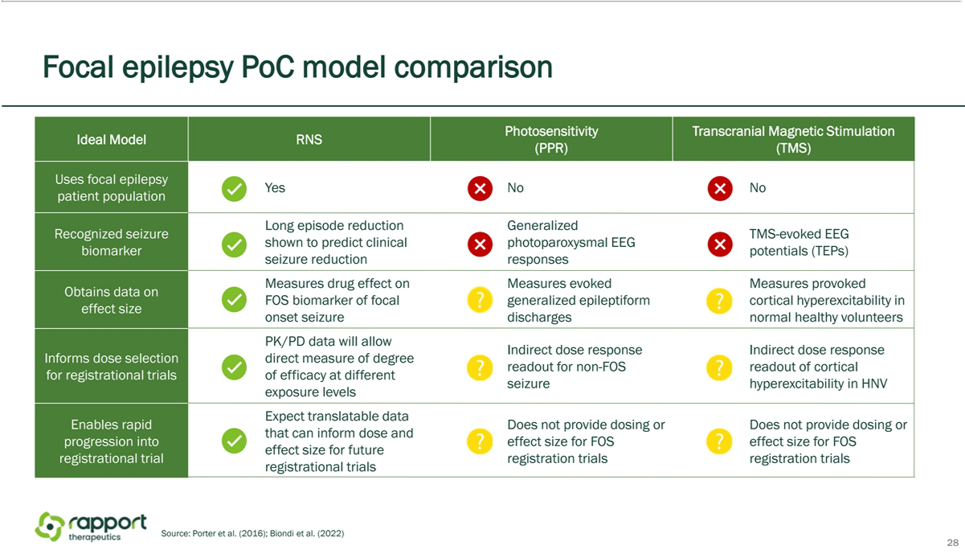

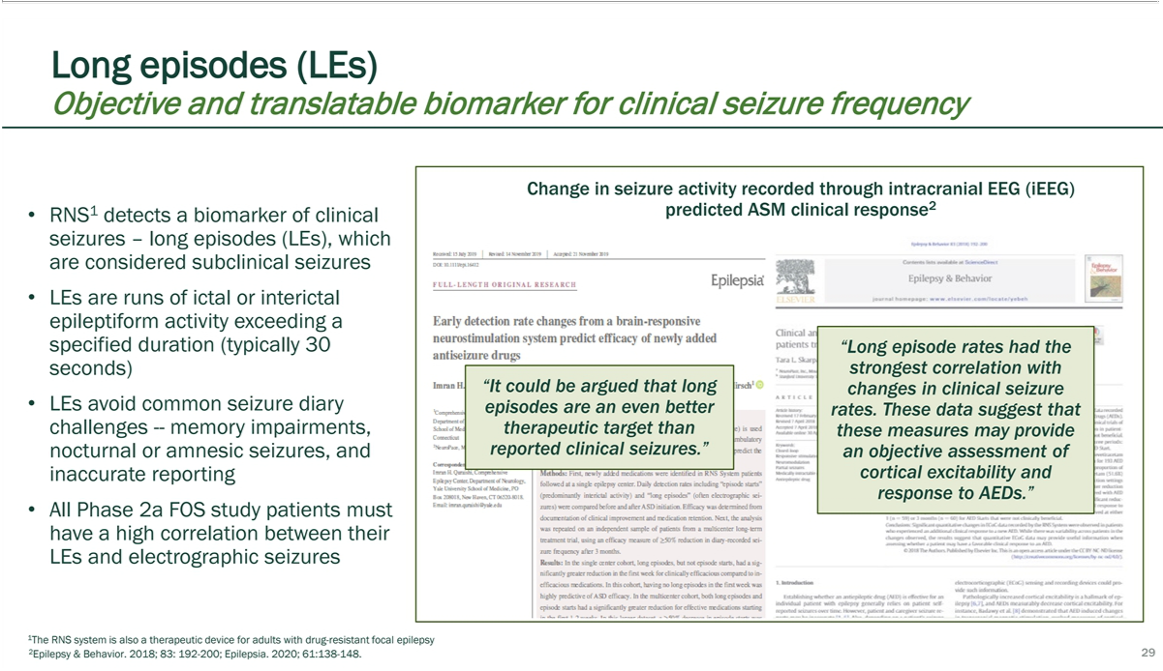

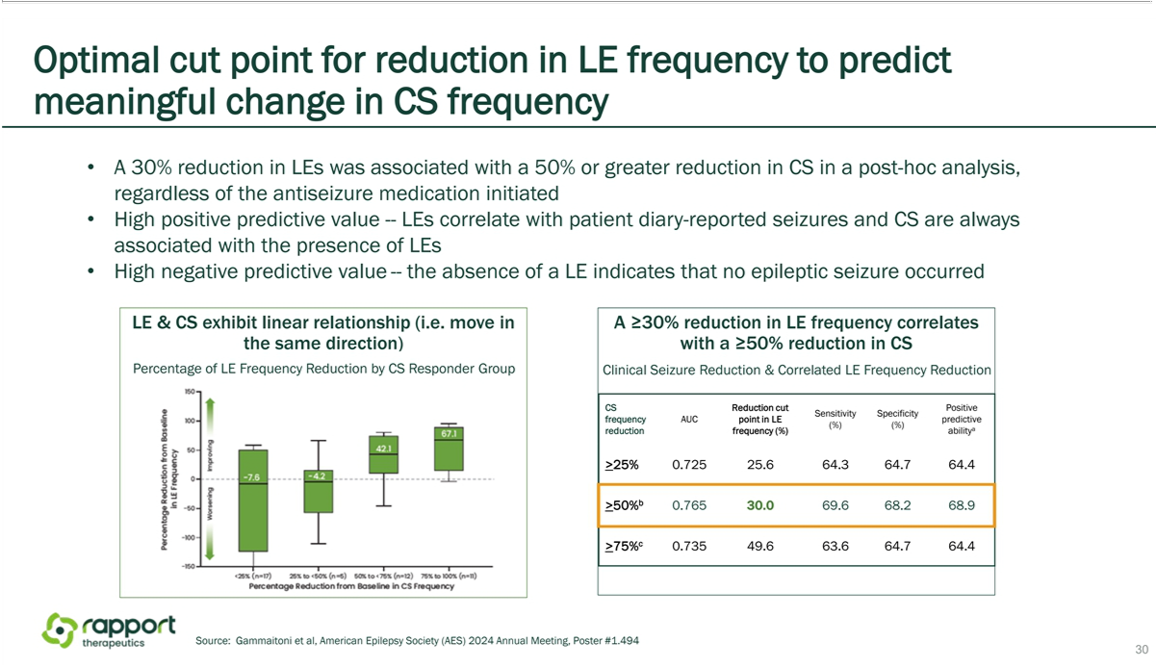

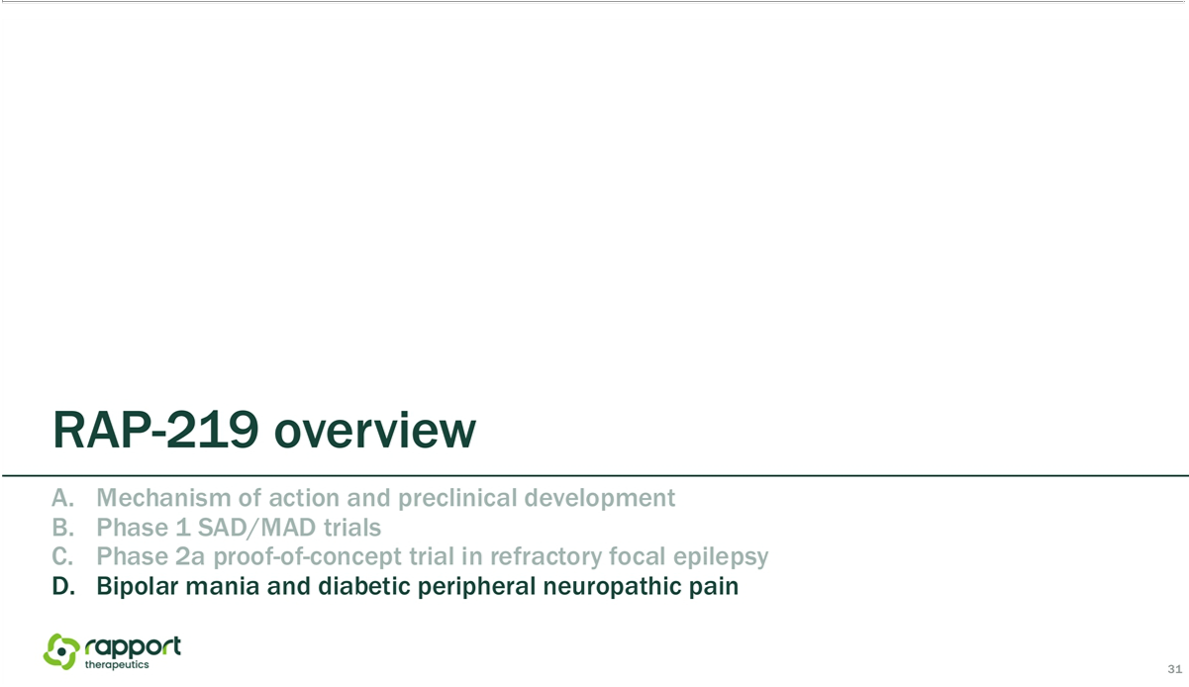

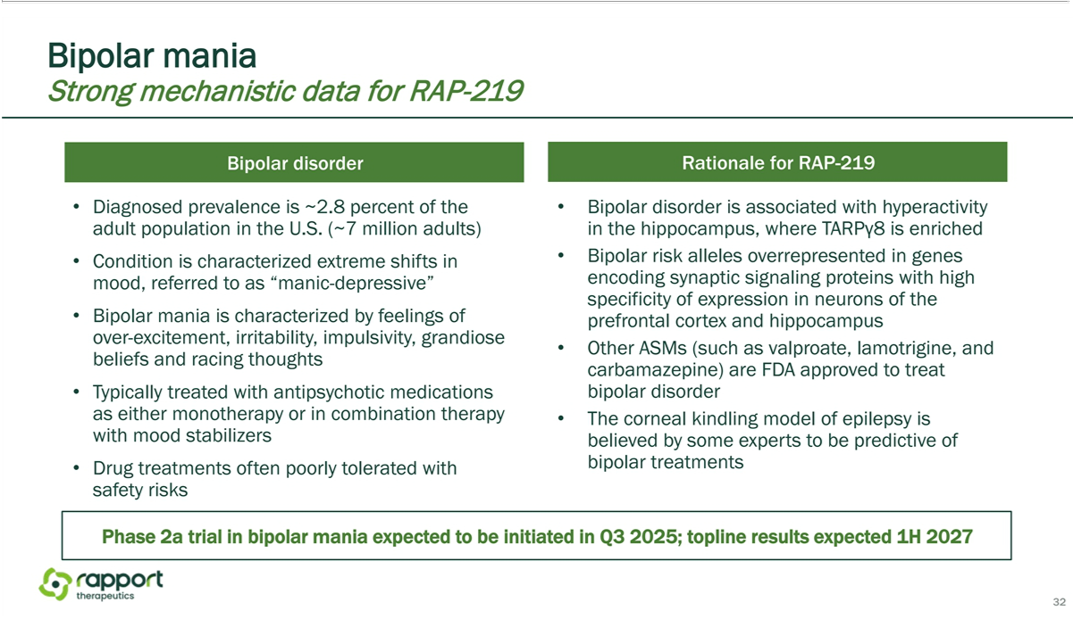

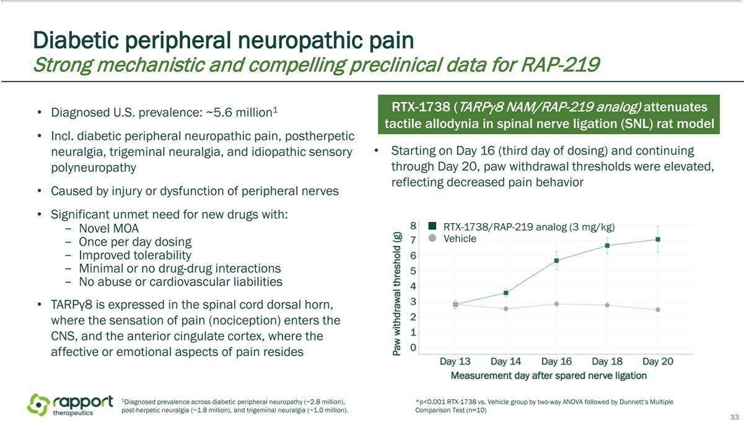

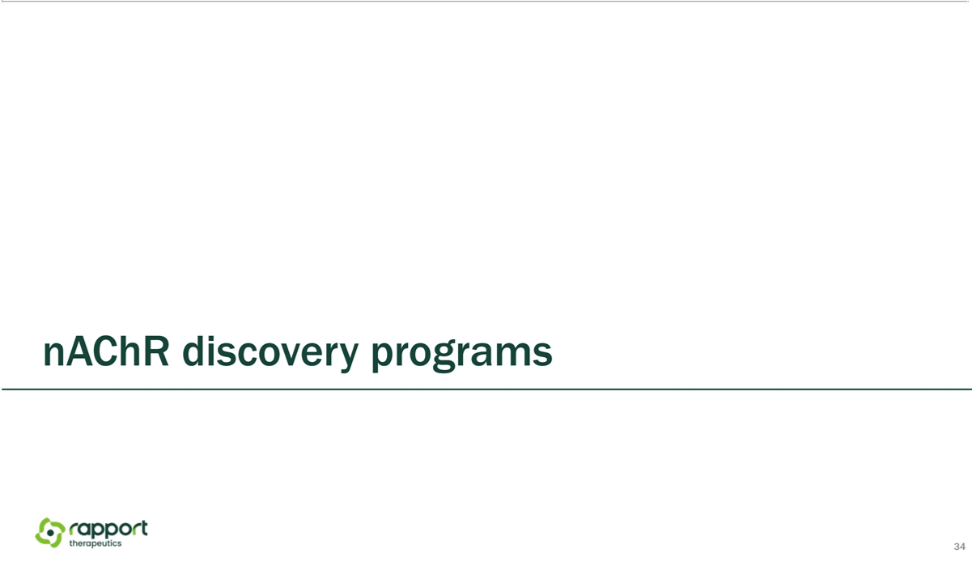

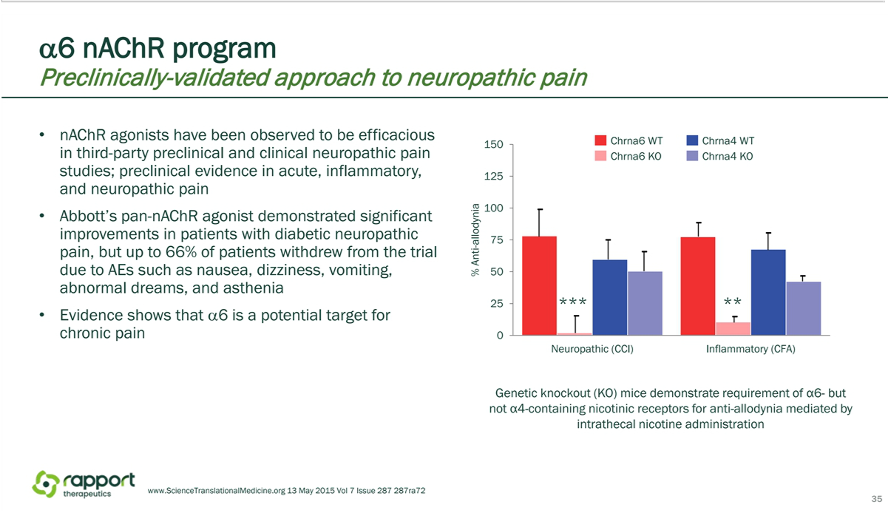

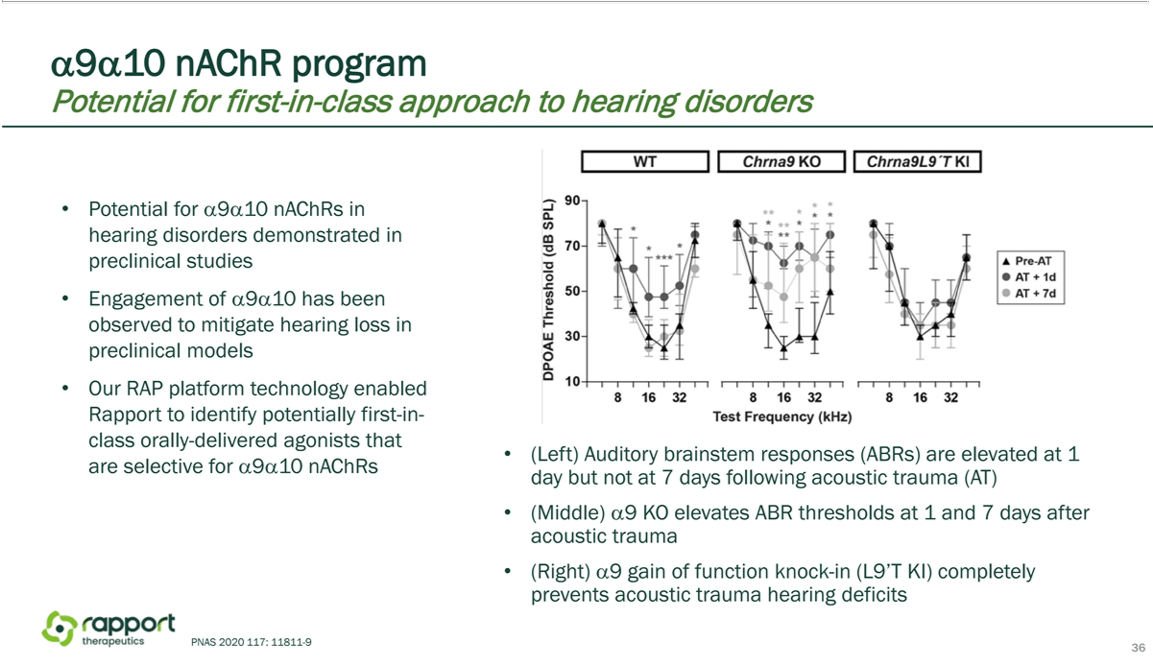

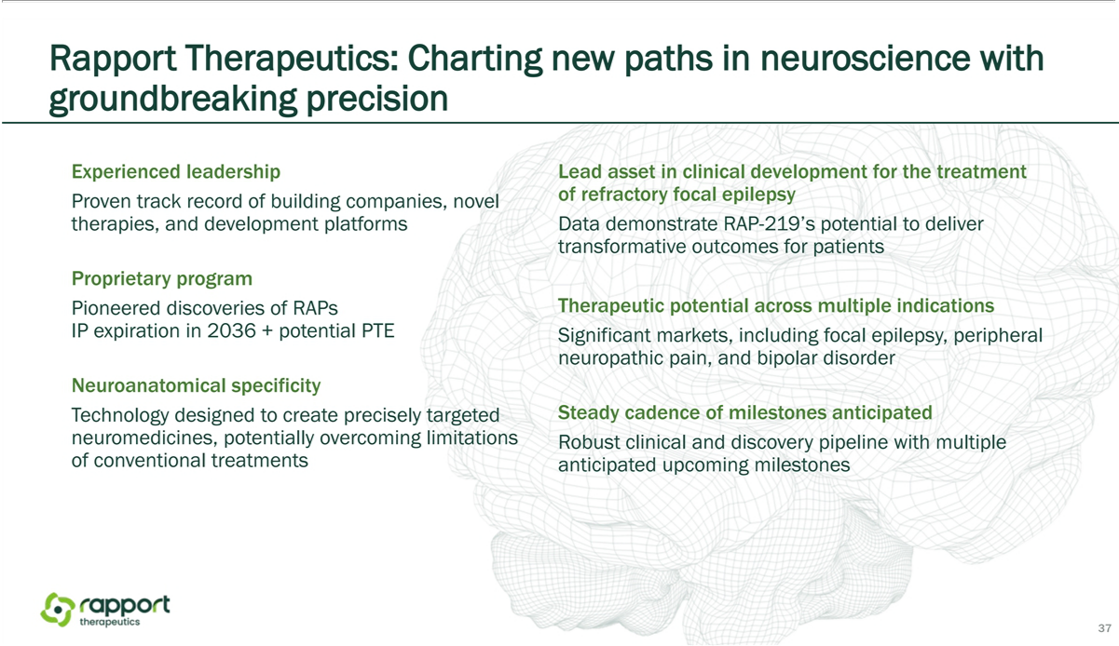



Exhibit 99.2


Rapport Therapeutics Announces Appointment of Dr. Jeffrey Sevigny as Chief Medical Officer to Drive Clinical Strategy and Precision Medicine Development

BOSTON and SAN DIEGO, March 3, 2025 – Rapport Therapeutics, Inc. (Nasdaq: RAPP), a clinical-stage biotechnology company dedicated to the discovery and development of small molecule precision medicines for patients suffering from central nervous system (CNS) disorders, today announced the appointment of Dr. Jeffrey Sevigny as chief medical officer (CMO), effective immediately. A physician-scientist with more than 15 years of leadership in translational and clinical drug development, Dr. Sevigny has spearheaded groundbreaking research across neuroscience and rare diseases. His experience spans the full spectrum of development, from discovery to late-stage clinical trials and regulatory approvals, and with a strong record of portfolio development and building high-performing organizations, he brings deep strategic and operational experience to Rapport.

Dr. Sevigny joins Rapport following his tenure as chief medical officer at Prevail Therapeutics, a wholly owned subsidiary of Eli Lilly, and senior vice president of Neuroscience at Eli Lilly. While at Prevail, Dr. Sevigny built and led the company’s clinical development organization, while playing a pivotal role in the company’s corporate success, including rounds of financing, an IPO, and an acquisition by Eli Lilly. His career has been marked by strong leadership in major pharmaceutical and biotech companies, where he has led highly effective translational and clinical development organizations, collaborative and successful interactions with regulatory authorities, and pioneering initiatives in neuroscience and other therapeutic areas.

In his role as CMO, Dr. Sevigny will oversee the development and execution of Rapport’s clinical strategy and will be responsible for ensuring the advancement of Rapport’s pipeline of precision medicines leveraging receptor associated protein (RAP) science. Building on the momentum of Rapport’s RAP-219 program, his proven ability to advance clinical programs through late-stage clinical trials and regulatory approval will be instrumental in progressing RAP-219 and the broader pipeline.

“We are thrilled to welcome Jeff to Rapport. His extensive experience leading successful clinical development programs and driving drug development in neuroscience make him the ideal addition to our executive team and leader of our clinical development capability,” said Abraham N. Ceesay, chief executive officer of Rapport. “Jeff’s proven ability in building effective teams, collaborating with regulatory authorities, and partnering with patient advocacy organizations to advance novel therapies will be invaluable as we continue advance our mission of bringing transformational treatments to patients living with neurological disorders worldwide.”

Throughout his career, Dr. Sevigny has held pivotal leadership roles at global pharmaceutical and biotech companies, including F. Hoffmann-La Roche, Biogen, Novartis, and Merck, where he contributed to significant advancements in neuroscience research and development. Beyond his industry roles, Dr. Sevigny has held academic appointments as assistant professor of Neurology at Albert Einstein School of Medicine and assistant professor of Clinical Neurology at Columbia University.

“I am honored to join Rapport and work with this exceptional team to lead a new era of precision neuroscience,” said Dr. Sevigny. “Rapport’s deep scientific foundation, compelling Phase 1 data from the RAP-219 program, and portfolio of potential clinical candidates set it apart from the field. With RAP-219 progressing through clinical development and key milestones on the horizon, I am eager to help bring this and other potentially transformative medicines to patients in need of better treatment options.”

About Rapport Therapeutics

Rapport Therapeutics is a clinical-stage biotechnology company dedicated to discovering and developing small molecule precision medicines for patients suffering from central nervous system (CNS) disorders. The Company’s founders have made pioneering discoveries related to the function of receptor associated proteins (RAPs) in the brain. Their findings form the basis of Rapport’s RAP technology platform, which enables a differentiated approach to generate precision small molecule product candidates with the potential to overcome many limitations of conventional neurology drug discovery. Rapport’s precision neuroscience pipeline includes the Company’s lead clinical program, RAP-219, designed to achieve neuroanatomical specificity through its selective targeting of a RAP expressed in only discrete regions of the brain. The Company is currently advancing RAP-219 in clinical trials in focal epilepsy, diabetic peripheral neuropathic pain, and bipolar mania. Additional preclinical and late-stage discovery stage programs are also underway, targeting CNS disorders including chronic pain and hearing disorders.

Forward-Looking Statements

This press release contains “forward-looking statements” within the meaning of Section 27A of the Securities Act of 1933 and Section 21E of the Securities Exchange Act of 1934, each as amended. The words “anticipate,” “believe,” “continue,” “could,” “estimate,” “expect,” “intend,” “may,” “plan,” “potential,” “predict,” “project,” “should,” “target,” “would” and similar expressions are intended to identify forward-looking statements, although not all forward-looking statements contain these identifying words. These forward-looking statements include, but are not limited to, express or implied statements regarding: the clinical development of RAP-219; the ability of RAP-219 and other products in Rapport’s pipeline to deliver transformative outcomes for patients; and Rapport’s RAP technology

platform. Forward looking statements are based on management’s current expectations and are subject to risks and uncertainties that could negatively affect Rapport’s business, operating results, financial condition, and stock value. Factors that could cause actual results to differ materially from those currently anticipated include: risks relating to the company’s research and development activities, including that interim, topline and preliminary data from our clinical trials that we announce or publish from time to time are subject to audit and verification procedures that could result in material changes in the final data; Rapport’s ability to execute on its strategy including obtaining the requisite regulatory approvals on the expected timeline, if at all; uncertainties relating to preclinical and clinical development activities; the company’s dependence on third parties to conduct clinical trials, manufacture its product candidates and develop and commercialize its product candidates, if approved; Rapport’s ability to attract, integrate and retain key personnel; risks related to the company’s financial condition and need for substantial additional funds in order to complete development activities and commercialize a product candidate, if approved; risks related to regulatory developments and approval processes of the U.S. Food and Drug Administration and comparable foreign regulatory authorities; risks related to establishing and maintaining Rapport’s intellectual property protections; and risks related to the competitive landscape for Rapport’s product candidates; as well as other risks described in “Risk Factors,” in the company’s Registration Statement on Form S-1, and most recent Quarterly Report on Form 10-Q, as well as discussions of potential risks, uncertainties, and other important factors in Rapport’s subsequent filings with the Securities and Exchange Commission. Rapport expressly disclaims any obligation or undertaking to release publicly any updates or revisions to any forward-looking statements contained herein to reflect any change in its expectations or any changes in events, conditions or circumstances on which any such statement is based, except as required by law, and claims the protection of the safe harbor for forward-looking statements contained in the Private Securities Litigation Reform Act of 1995.

Contact:

Julie DiCarlo

Head of Communications & IR

Rapport Therapeutics

jdicarlo@rapportrx.com

